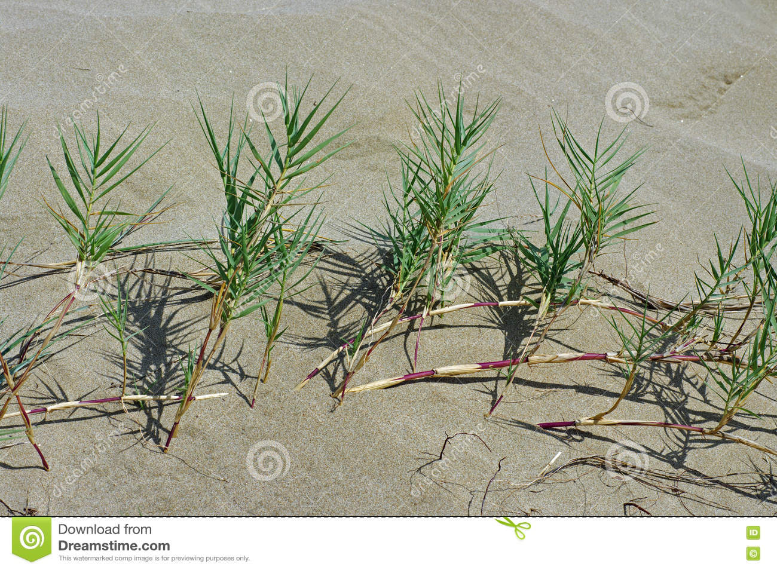 | SCIENTIFIC NAME: sporobolus virginicus
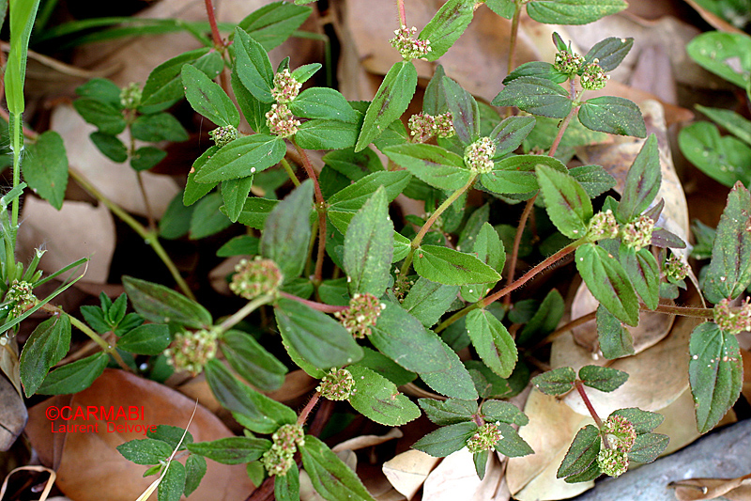 | SCIENTIFIC NAME:  euphorbia mesembrianthemifolia
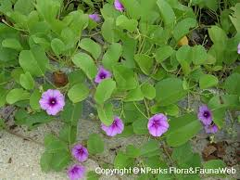 | SCIENTIFIC NAME: ipomoea pes-caprae
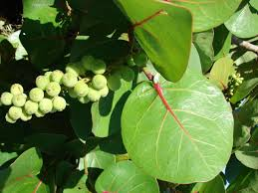 | coccoloba uvifera
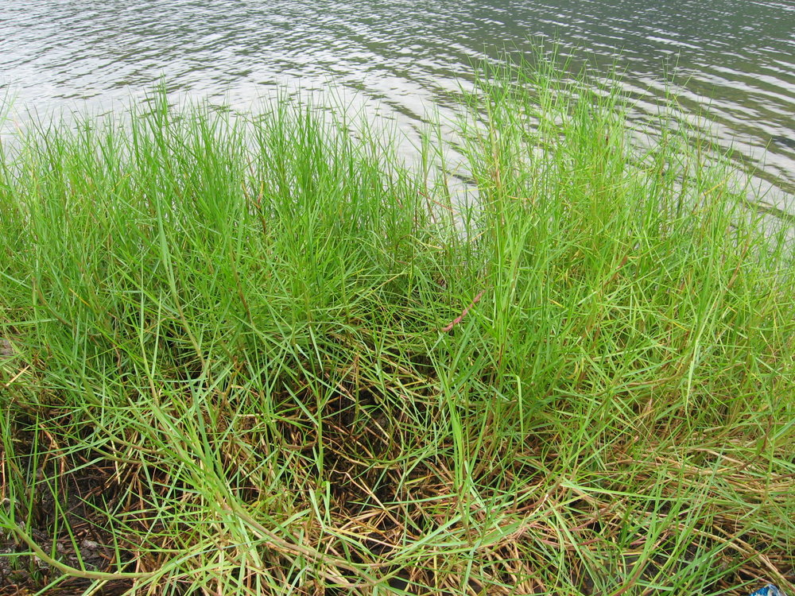 | Paspalum vaginatum
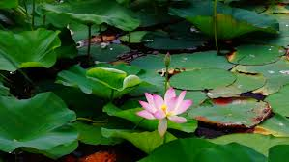 | Nelumbo nucifera
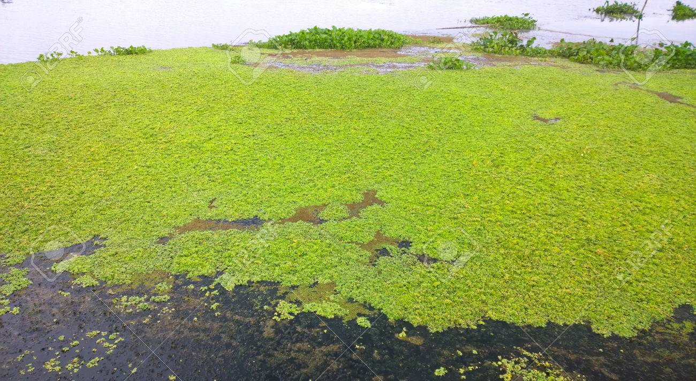 | Water lettuce
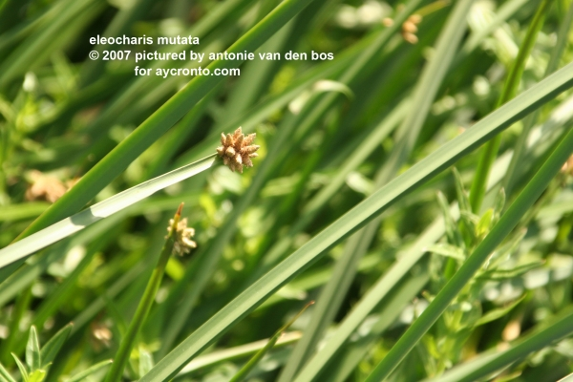 | Eleocharis mutata.

