The Relationship between Population Growth and Sustainable Development
What is Sustainable Development?
Sustainable development has been defined in many ways, but the most frequently quoted definition is from Our Common Future, also known as the Brundtland Report:^{[1]}
Sustainable development is development that meets the needs of the present without compromising the ability of future generations to meet their own needs.
The World Bank has also defined sustainability in terms of opportunities for future generations, using a triangular framework to illustrate the idea of Environmentally Sustainable Development (ESD).
The new framework includes economic, social and ecological objectives, Broadly put, the goal of sustainable development is to further each of these objectives (economic, social and ecological) simultaneously over the long term, so that they may be enjoyed by future generations.
As mentioned before there are three dimensions to sustainable development:
- economic,
- social
- and environmental.
These dimensions give rise to the need for the planning system to perform a number of roles:
an economic role – contributing to building a strong, responsive and competitive economy, by ensuring that sufficient land of the right type is available in the right places and at the right time to support growth and innovation; and by identifying and coordinating development requirements, including the provision of infrastructure;
a social role – supporting strong, vibrant and healthy communities, by providing the supply of housing required to meet the needs of present and future generations; and by creating a high quality built environment, with accessible local services that reflect the community’s needs and support its health, social and cultural well-being; and
an environmental role – contributing to protecting and enhancing our natural, built and historic environment; and, as part of this, helping to improve biodiversity, use natural resources prudently, minimise waste and pollution, and mitigate and adapt to climate change including moving to a low carbon economy.

GOALS OF SUSTAINABLE DEVELOPMENT
The Sustainable Development Goals (SDGs) are a proposed set of targets relating to future international development.

Goals, targets and indicators

DEFINITION of indicators

a thing, especially a trend or fact, that indicates the state or level of something.

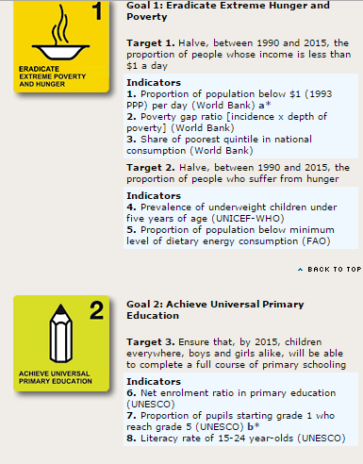
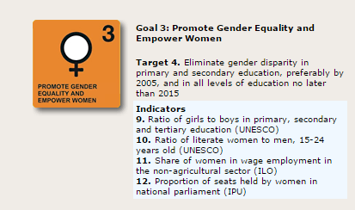
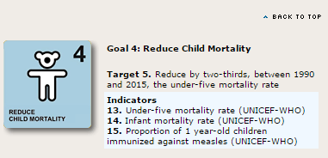
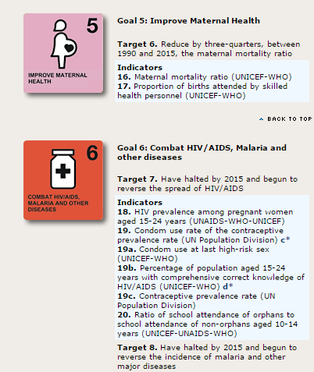

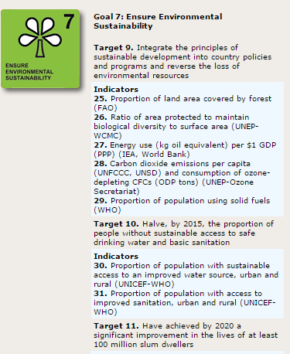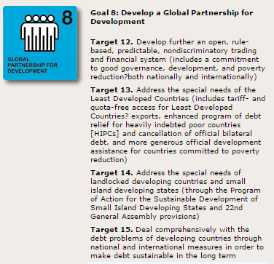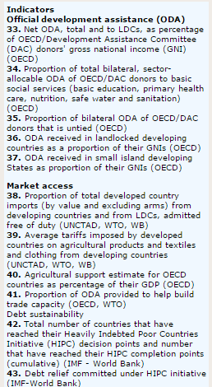

The Relationship between Population Growth and Sustainable Development
Population growth increases environmental pressures:
Out of the 7 billion people that currently inhabit the world, more than 1 billion continue to live in extreme poverty. About as many suffer from food insecurity (FAO, 2008) and live in slums (UN Habitat, 2010; UNFPA, 2007), and millions are unable to find productive and remunerative employment
Population growth increasingly differs between countries: Pressures are mounting in the world’s poorest countries
The growth of the world population masks considerable differences between countries. Over the past decades the heterogeneity amongst countries and within countries has increased considerably as regards population growth. Whereas populations are stabilizing or declining in many developed countries, and population growth is decelerating in many of the middle-income countries, population growth remains high in the world’s least developed countries.
To create full employment, raise household incomes and combat poverty, the least developed countries require higher and more sustained economic growth (UNCTAD, 2002; 2006; 2008). But higher economic growth will also increase environmental pressures within the current development regime. This is particularly true where economic growth is based on extractive and carbon-intensive industries but also where agricultural production further erodes natural resources. The world’s least developed countries are more strongly affected by environmental degradation than most other developing countries (UNFPA, 2011a; UNCTAD, 2011), and this, along with high population growth, affects their prospects for development.
Population growth differs within countries: Rapid urbanization changes vulnerabilities and creates new opportunities
The world is undergoing the largest wave of urban growth in history: already, over half the world’s population is living in towns and cities, and by 2030 this number will swell to almost 5 billion, with urban growth concentrated in Africa and Asia. Rural-urban migration is often motivated by economic opportunities, but economic opportunities are also closely related to changing environmental conditions. Flooding in the delta of Bangladesh, and droughts in the horn of Africa (Herrmann and Svarin, 2009), for example, threaten livelihoods in the rural areas and encourage many to search for a more prosperous life in the urban centers. And as environmental shocks increase in frequency and intensity, they can further accelerate rural-urban migration Under the right circumstances, and with the right supports, migration can be a strategy to adapt to changing environmental conditions, rather than a failure to adapt.
Despite the challenges that are associated with urbanization, it can be a powerful driver for sustainable economic, social and environmental development (UNFPA, 2007; McKinsey Global Institute, 2011). As populations grow, it makes economic and environmental sense for people to move closer together in urban areas.
Urbanization enables countries to provide essential services, including health and education, at lower costs per capita, and also allows for economies of scale in the development of vital infrastructure, including housing, water, sanitation and transport. Urbanization can also reduce energy consumption, particularly in transport and housing, and it can help to ease population pressures in rural areas.
Changes in the size of populations are inevitably bringing about changes in the age-structure of populations. Countries that have high population growth have youthful populations, whereas the countries that have low population growth have an aging population. Changing age structures affect not only patterns of consumption and production; they also affect the balance between, returns to and investment in the different factors of production. They have important implications for labor markets, wages and income distribution, as well as current and future output (Lewis, 1954; Fei and Ranis, 1964).

