The Environmental Impacts of Urbanization
Urbanisation means an increase in the proportion of people living in urban areas compared to rural areas. An urban area is a built-up area such as a town or city. A rural area is an area of countryside.
CASE STUDY: Causes and Effects of Urbanization in India
Urbanization: Causes and Effects of Urbanization in India!
Urbanisation has become a common feature of Indian society. Growth of Industries has contributed to the growth of cities. As a result of industrialisation people have started moving towards the industrial areas in search of employment. This has resulted in the growth of towns and cities.
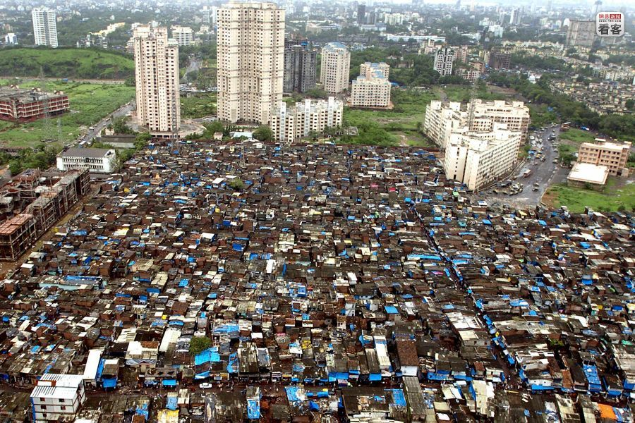
According to Mitchell urbanisation is a process of becoming urban, moving to cities, changing from agriculture to other pursuits common to cities.
Causes of Urbanisation:
Various reasons have led to the growth of cities. They are as follows:
i. Industrialization:
Industrialization is a major cause of urbanization. It has expanded the employment opportunities. Rural people have migrated to cities on account of better employment opportunities.
ii. Social factors:
Many social factors such as attraction of cities, better standard of living, better educational facilities, need for status also induce people to migrate to cities.
iii. Employment opportunities:
In rural sector people have to depend mainly on agriculture for their livelihood. But Indian agriculture is depending on monsoon. In drought situations or natural calamities, rural people have to migrate to cities.
iv. Modernization:
Urban areas are characterized by sophisticated technology better infrastructure, communication, medical facilities
, etc. People feel that they can lead a comfortable life in cities and migrate to cities.
Rural urban transformation:
It is an interesting aspect that not only cities are growing in number but rural community is adopting urban culture, no longer rural communities are retaining their unique rural culture. Rural people are following the material culture of urban people. Urban rural transformation can be observed in the following areas.
Spread of education:
The literacy rate has increased among the rural people. They have become more modernised.
Change in Dress habits.

Adoption of modern Technology

iii. Enlightenment of women.

iv. Modern transport and communication. E.g.: Cell phones have become common even among rural people.

v. Active involvement in politics.

vi. Growth of infrastructure like Banks, Post office.

vii. Awareness among rural consumers.

viii. Increasing demand for sophisticated products like cosmetics etc.

Thus it can be noticed that there are significant changes in the life style of village people. Indian villages have adopted urban culture and urban style of living. However, all villages in India are not transformed. Only certain villages situated close to the cities have been transformed.

Effect of Urbanisation:
With a high rate of urbanization significant changes have taken place. The effect of urbanisation can be summed up as follows:
Positive effect:
i. Migration of rural people to urban areas.
ii. Employment opportunities in urban centres.
iii. Transport and communication facilities.
iv. Educational facilities.
v. Increase in the standard of living.
Urbanization can yield positive effects if it takes place up to a desirable limit. Extensive urbanisation or indiscriminate growth of cities may result in adverse effects. They may be as follows:
Problem of over population:
Concentration of population is a major problem of cities. It has resulted in accommodation problem, growth of slums etc.
ii. Disintegration of Joint family:
Joint family can’t be maintained in cities on account of high cost of living: People prefer to live in the nuclear type of families.
iii. Cost of living:
High cost of living is a major problem of cities. In Metro cities like Mumbai, Bangalore etc. it is very difficult for lower income groups to maintain a decent standard of living.
iv. Increase in Crime rates:
Urban centres are known for high rate of crimes. Theft, Murder, Cheating, Pick pocketing, rape etc. are common in urban centres.
v. Impersonal relations:
Urban centres are characterised by highly secondary relations. The concept of neighbourhood, community life are almost absent in cities. Urban life is highly monotonous. This may have an adverse psychological effect on individuals. People are often self-centred and they have no concern for the fellow human beings.

vi. Problem of Pollution:
In industrialized cities pollution is a major problem. It may be caused by industries or by excessive movement of vehicles.
viii. Stress:
Urban life is characterised by stress which may even strain family relations. In cities employment of women is almost inevitable to meet the increasing cost of living. Changing role of women in the family creates stress in the family which may result in divorce or strained relations.
Thus urbanisation has its own merits and de-merits. Urbanization can’t be avoided. But the negative effect of urbanization can be minimised.

