Demographic Data
Objectives
Students should be able to: CHECKLIST
- Recognise a population pyramid □
- Construct a population pyramid □
- Analyse a population pyramid □
- Understand the terms fertility rate, mortality rate and birth rate □

Demographics is defined as statistical data about the characteristics of a population, such as the age, gender and income of the people within the population.
Population pyramids
A population pyramid, is a graphical illustration that shows the distribution of various age groups in a population which forms the shape of a pyramid when the population is growing.
It typically consists of two back-to-back bar graphs, with the population plotted on the X-axis and age on the Y-axis, one showing the number of males and one showing females in a particular population in five-year age groups (also called cohorts). Males are conventionally shown on the left and females on the right.
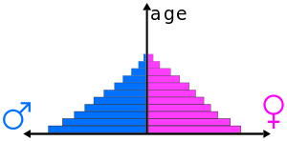

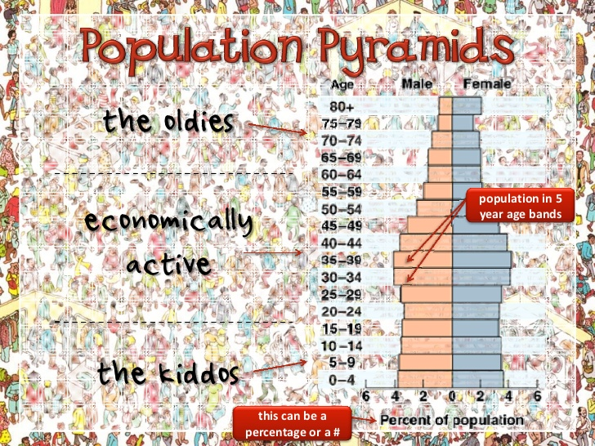
COHORTS!
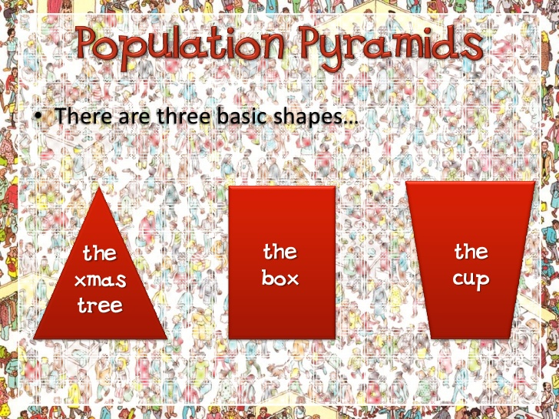
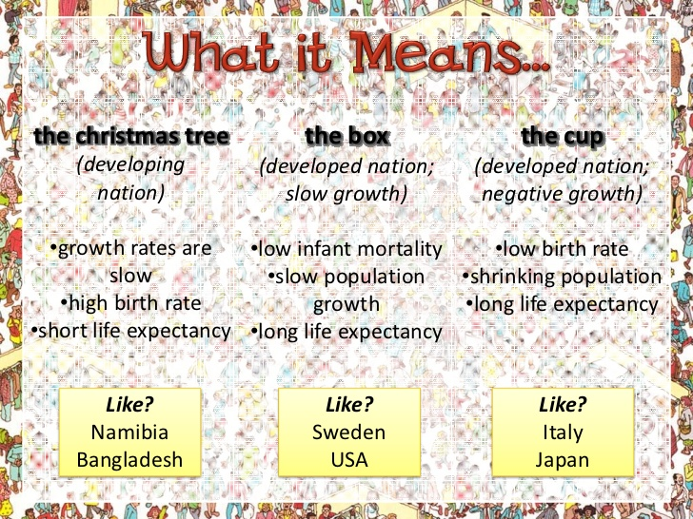
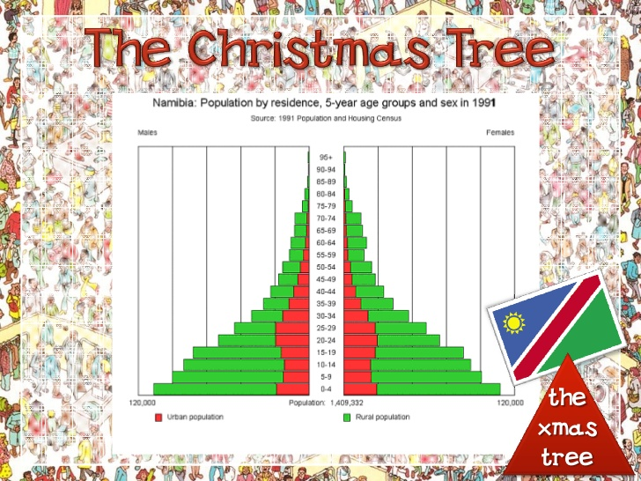
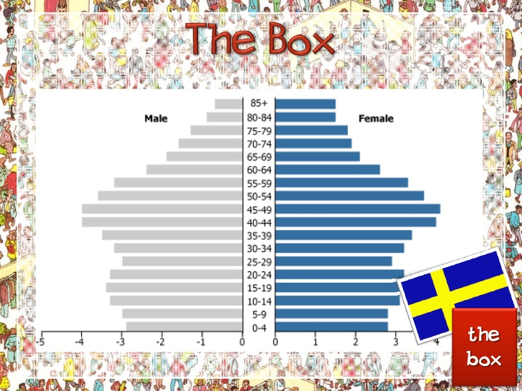
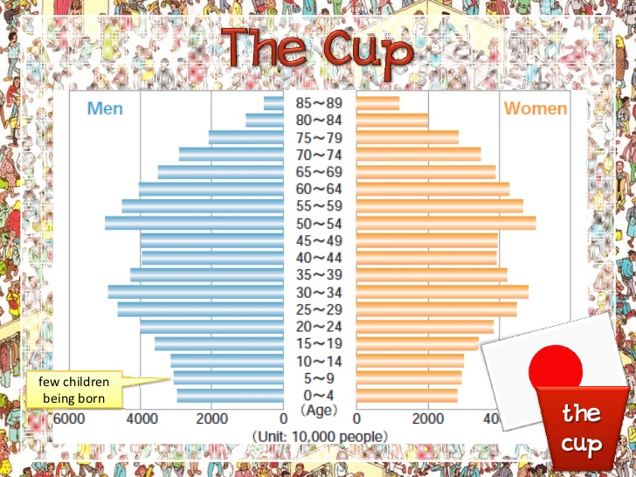

How to read a population pyramid
- The width of the base is an indication of the birth rate of the country
- A wide base indicates a high birth rate while a narrow one shows the opposite.
- An asymmetrical pyramid indicates that there is a difference in male and female populations. Depending on the stage at which the asymmetry is found, this could be due to loss in wars or life expectancy.

- The shape of the sides also conveys information about death rates. The more concave ( the sides , the higher the death rate. Straight sides indicate a low death rate.
- Irregular or bumpy sides in the pyramid may indicate anomalies like a baby boom period or an influx of migrant workers and their families.
Population Pyramids are related to the stages of the Demographic Transition Model (DTM )
The demographic transition model
The demographic transition model shows population change over time. It studies how birth rate and death rate affect the total population of a country.
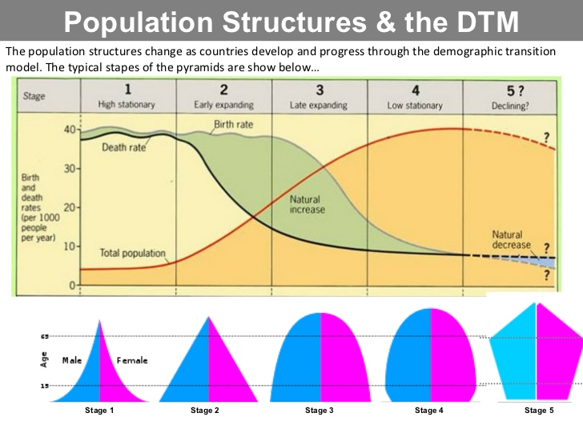

The five stages of the demographic transition model
- Total population is low but it is balanced due to high birth rates and high death rates.
- Total population rises as death rates fall due to improvements in health care and sanitation. Birth rates remain high.
- Total population is still rising rapidly. The gap between birth and death rates narrows due to the availability of contraception and fewer children being needed to work - due to the mechanisation of farming. The natural increaseis high.
- Total population is high, but it is balanced by a low birth rate and a low death rate. Birth control is widely available and there is a desire for smaller families.
- Total population is high but going into decline due to an ageing population. There is a continued desire for smaller families, with people opting to have children later in life.
As a country passes through the demographic transition model, the total population rises. Most LEDCs are at stage 2 or 3 (with a growing population and a high natural increase). Most MEDCs are now at stage 4 of the model and some such as Germany have entered stage 5.
As populations move through the stages of the model, the gap between birth rate and death rate first widens, then narrows. In stage 1 the two rates are balanced. In stage 2 they diverge, as the death rate falls relative to the birth rate. In stage 3 theyconverge again, as the birth rate falls relative to the death rate. Finally in stage 4 the death and birth rates are balanced again but at a much lower level.

Limitations of the model
- The model was developed after studying the experiences of countries in Western Europe and North America. Conditions might be different for LEDCs in different parts of the world.
- The original model doesn't take into account the fact that some countries now have a declining population and a 5th stage. Most texts will now show this stage as it is relevant to an increasing number of MEDCs in the 21st century.

Fertility, Mortality and Birth Rates
Fertility, mortality and birth rates are other forms of demographic data which provide a picture a population’s status and could be used to predict population trends in the future.
Fertility Rate
Fertility rate, total (births per woman)
Total fertility rate represents the number of children that would be born to a woman if she were to live to the end of her childbearing years and bear children in accordance with current age-specific fertility rates. Higher rates are seen in LEDC e.g. Burundi -5.9, Niger – 7. Whilst, more developed countries have low rates e.g. Germany -1.4, Sweden -1.7.
Mortality Rate
Mortality rate - the ratio of deaths in an area to the population of that area; expressed per 1000 per year regardless of age group.
- This indicator is affected by age distribution and tends to show an increase in developed countries as the population ages e.g. Germany’s mortality rate is 1.1. In countries with war or civil conflicts mortality rates are high e.g. Sudan 17.
Birth Rate
The crude birth rate is the number of live births occurring among the population of a given geographical area during a given year, per 1,000 of the population of the given geographical area during the same year. The birth rate is the major factor which determines overall population growth rate along with fertility rate and age structure. E.g. Niger – 46.8, France – 12.6, Singapore -7.9.

Exercise
