I have matched the topics with the number of the page in your text book.
METALS AND NON-METALS
- What are the advantages and disadvantage of using plastics? Page 205
- What are the advantages and disadvantages of using aluminium in cooking or as canning material? Pg203
- Methods of cleaning household appliances. Pg210-211
- The benefits of using alloys to make household items. Pg202-203

ACIDS .BASES and SALTS
- Household chemicals Pgs 222 -225
- Distinguish between acids bases and salts. Pg 220-221
- Distinguish between solutions, suspensions and colloids. Pg 216
- Explain how solvents remove stains. 217,221
- The safe and economic use of some common household chemicals. 223
- Distinguish between hard and soft water… 218
- Explain what scouring powders are made of and how they work …. 211
- Differences between soapy and soapless detergents ….206-207

Electricity
- What are good and poor conductors of electricity….172

Electricity is the flow of electrons. If a material is going to CONDUCT electricity , it must have electrons of its own that will be free to move between the atoms (that make it up).Metals are such materials.
CONDUCTORS and NON-CONDUCTORS

Solid conductors, such as metals have free electrons. So does the non-metal carbon, when it is in the form of graphite. When they materials are included in a circuit (An electric circuit is a path in which electrons from a voltage or current source flow) , the electrons can flow and the material conducts electricity. Copper and aluminium is used as electrical wires, carbon rods are used as electrolytes.

Liquid conductors,such as acids,alkalis and salt solution contain charged ions. The ions are free to move and carry an electric current. The liquids are called electrolytes. Sulphuric acid is an electrolyte and is used in car batteries. Mercury is a metal that is a liquid at room temperature and it is also a conductor.

Non-conductors are INSULATORS, such as rubber, plastic and wood. Their electrons are all held tightly to the atoms which make them up. So the electrons cannot move and the material cannot conduct electricity. Plastic and rubber are used for covering wires to protect us from the electricity.

Semi –Conductors --- 173

- What is Voltage, Current and Resistance in circuits….

Electric current
When electric charges move in a wire, we say that an electric current flows in the wire. It's like the way a current of water flows in a river.
For an electric current to flow, we need two things:
- something to make the electricity flow, such as a battery or power pack
- a complete path for the current to flow in. This is called an electric circuit
- Electricity is measured in watts
Watt - A unit for measuring electric power.
- 1 Kilowatt = 1000 watts.
- 1 Megawatt = 1,000,000 watts.

Electric circuits
An electric current will not flow if we do not have a power source (a cell, battery or power pack). It also won't flow if the circuit is not complete. One end of the power source must be joined to the other end by the wires and components of the circuit.
The simplest complete circuit is a piece of wire from one end of a battery to the other. An electric current can flow in the wire from one end of the battery to the other, but nothing useful happens. The wire just gets hot and the battery goes flat.
To do something useful with the electric current, we need to put an electrical component into the circuit, such as a lamp or motor, that can use the current to make something happen.
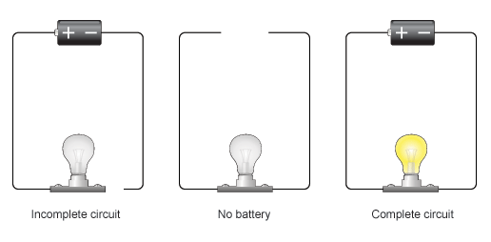
We usually add in a switch to the circuit, so that we can break the circuit and stop the electric current when we want to.
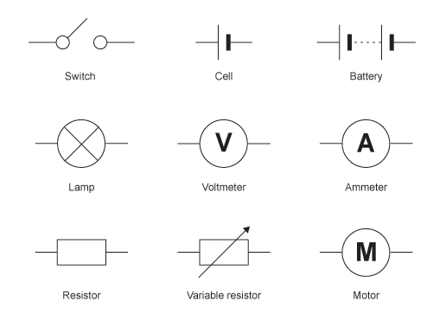

Cells and batteries
Notice the difference between the symbol for a cell and the symbol for abattery? The battery is made from joining cell symbols together.
Think of what we usually call a single battery, like the type you put in a torch. In physics, each of these is actually called a cell - it is only when you have two or more of these cells connected together that you call it a battery.

Circuit diagrams
The idea of a circuit diagram is to use circuit symbols instead of drawing each component in the circuit. Always try to make the wires straight lines, and don't be tempted to make them wiggly.
The whole point is to make it easier to see what is connected to what. Here you can see how the symbols for a cell (not a battery!) and a lamp look in a circuit diagram.
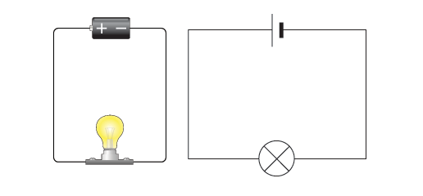
If you have to draw a circuit diagram from scratch, it is usually easier to draw the circuit symbols first, and then add all the wires. If you have to draw wires to join circuit symbols that are already shown, use a ruler and don't let the wires cross each other.

Series & parallel circuits
There are two types of circuit we can make, called series and parallel.
The components in a circuit are joined by wires.
- if there are no branches then it's a series circuit
- if there are branches it's a parallel circuit

Series circuits
In a television series, you get several episodes, one after the other. A series circuit is similar. You get several components one after the other.
If you follow the circuit diagram from one side of the cell to the other, you should pass through all the different components, one after the other, without any branches.
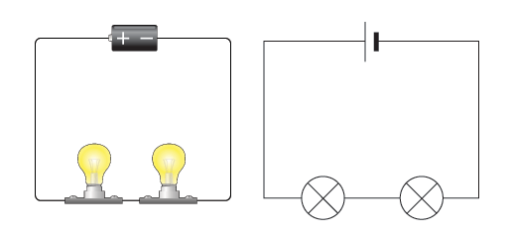
If you put more lamps into a series circuit, the lamps will be dimmer than before.
In a series circuit, if a lamp breaks or a component is disconnected, the circuit is broken and all the components stop working.
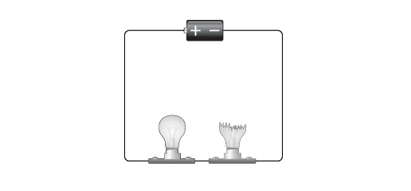
Series circuits are useful if you want a warning that one of the components in the circuit has failed. They also use less wiring than parallel circuits.

Parallel circuits
In parallel circuits different components are connected on different branches of the wire. If you follow the circuit diagram from one side of the cell to the other, you can only pass through all the different components if you follow all the branches.
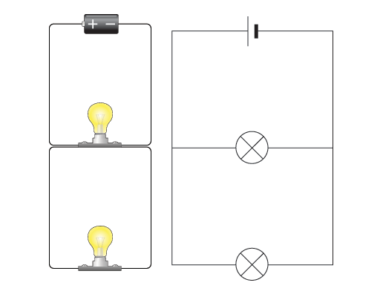
In a parallel circuit, if a lamp breaks or a component is disconnected from one parallel wire, the components on different branches keep working. And, unlike a series circuit, the lamps stay bright if you add more lamps in parallel.
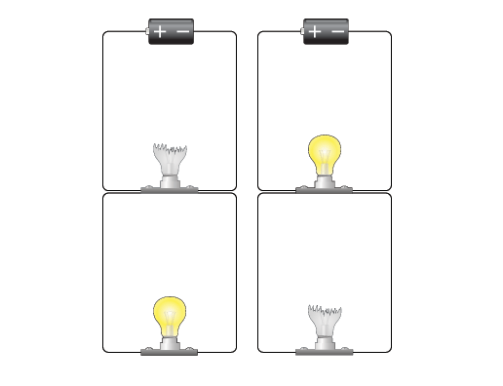
Parallel circuits are useful if you want everything to work, even if one component has failed. This is why our homes are wired up with parallel circuits.
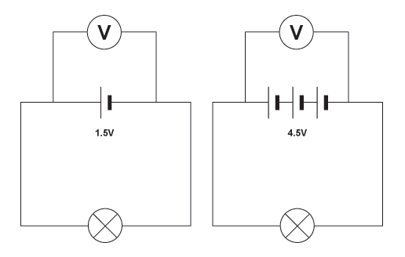

Measuring amps & volts
You need to know how to measure current and voltage.

Current
Current (I) is a measure of how much electric charge flows through a circuit. The more charge that flows, the bigger the current.
Current is measured in units called amperes or amps for short. The symbol for amps is A. For example, 20A is a bigger current than 5A.
A device called an ammeter is used to measure current. Some types of ammeter have a pointer on a dial, but most have a digital readout. To measure the current flowing through a component in a circuit, you must connect the ammeter in series with it.
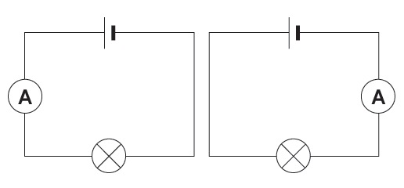

Voltage
Voltage is a measure of the difference in electrical energy between two parts of a circuit. The bigger the difference in energy, the bigger the voltage /or how hard the current is being pushed around the circuit
Voltage is measured in volts. The symbol for volts is V. For example, 230V is a bigger voltage than 12V.
Voltage (V) = Current (I) x Resistance (R)
V=IR

Measuring voltage
Voltage is measured using a voltmeter. Some types of voltmeter have a pointer on a dial, but most have a digital readout. To measure the voltage across a component in a circuit, you must connect the voltmeter in parallel with it.
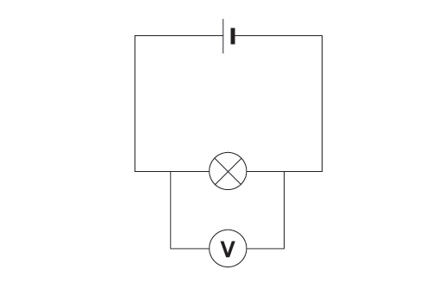
Using a voltmeter to measure the voltage across a lamp
You can measure the voltage across a cell or battery. The more cells, the bigger the voltage.
The more cells, the bigger the voltage.

Current in series circuits
The current is the same everywhere in a series circuit. It does not matter where you put the ammeter, it will give you the same reading.
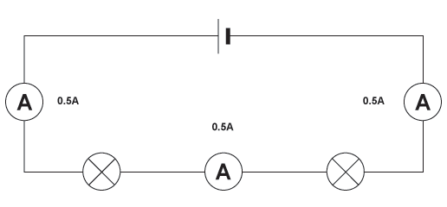 All three ammeters give the same reading in this series circuit

Adding more cells
The current in a series circuit depends upon the number of cells. The more cells you add, the greater the current.
All three ammeters give the same reading in this series circuit
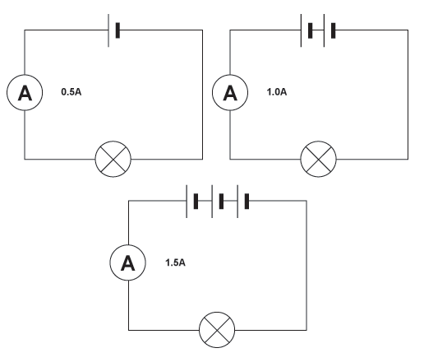

Why is Resistance Important?
Resistance (R) is the opposition to the passage of electricity or All conductors show some opposition to electrical current. This opposition to current is called resistance. It is measured in ohms and represented by the symbol
See page 176, practice calculations

3.How to use electricity safely ----- pgs 180-183

4.How to calculate electricity bills----- pgs 178-179
5. The magnetic effects of electrical currents ---pgs 184

